CSA1701-ARTIFICIAL INTELLIGENCE

NAME: A. Sri rama krishna
REG NO:192465011

8-Puzzle Problem – Lab Experiment
Aim:
To write a Python program to solve the 8-Puzzle problem using Breadth First Search.

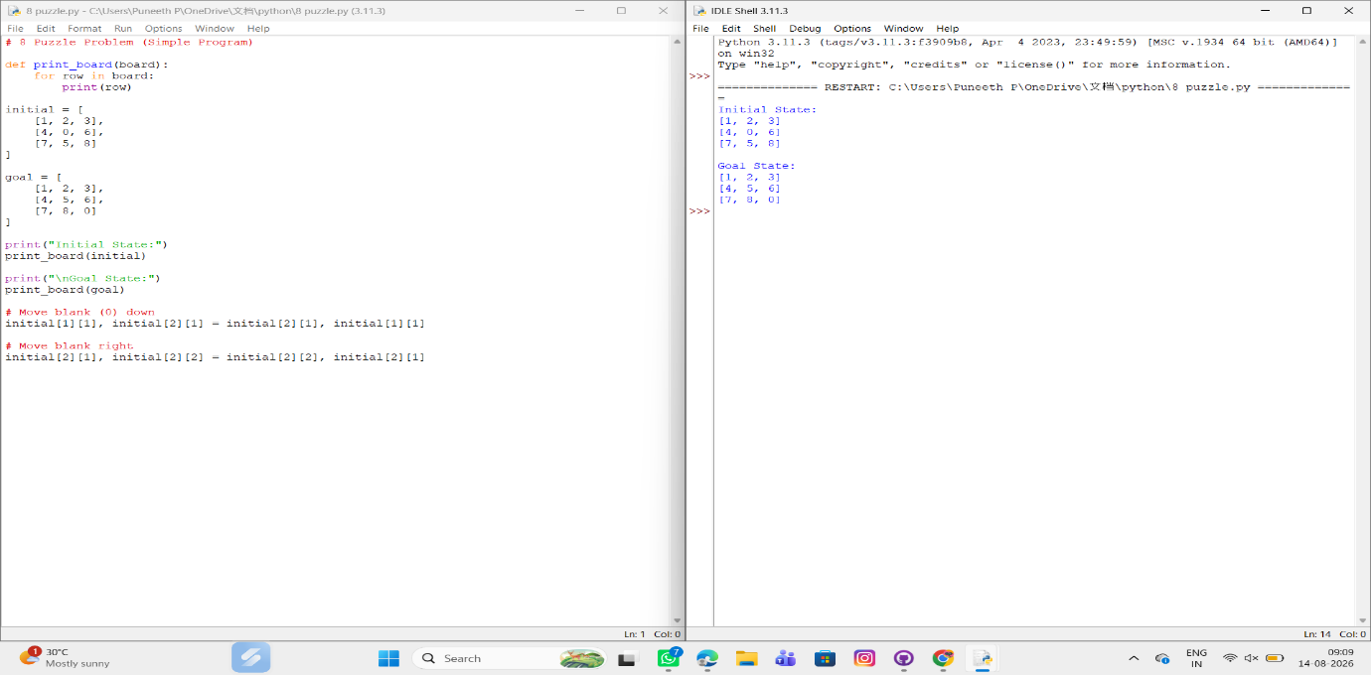

RESULT:
Thus, the 8-Puzzle problem was successfully solved using the BFS algorithm in Python.

